Overview of the practical exam for 2365 1
Light switch Step one 2
Light Switch Step Two 2
Light switch Step three 3
Steel conduit - Ring Circuit 3
SWA Radial Circuit 3

The overall schematic for the circuit board that I have to design.

Overview of the practical exam for 2365

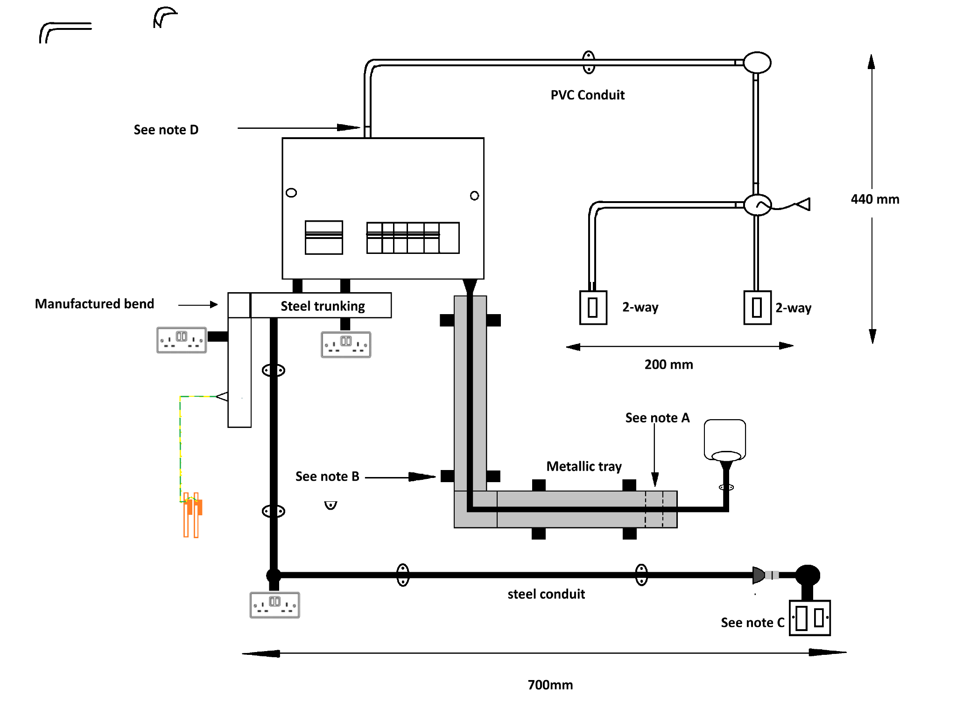

Light switch Step one
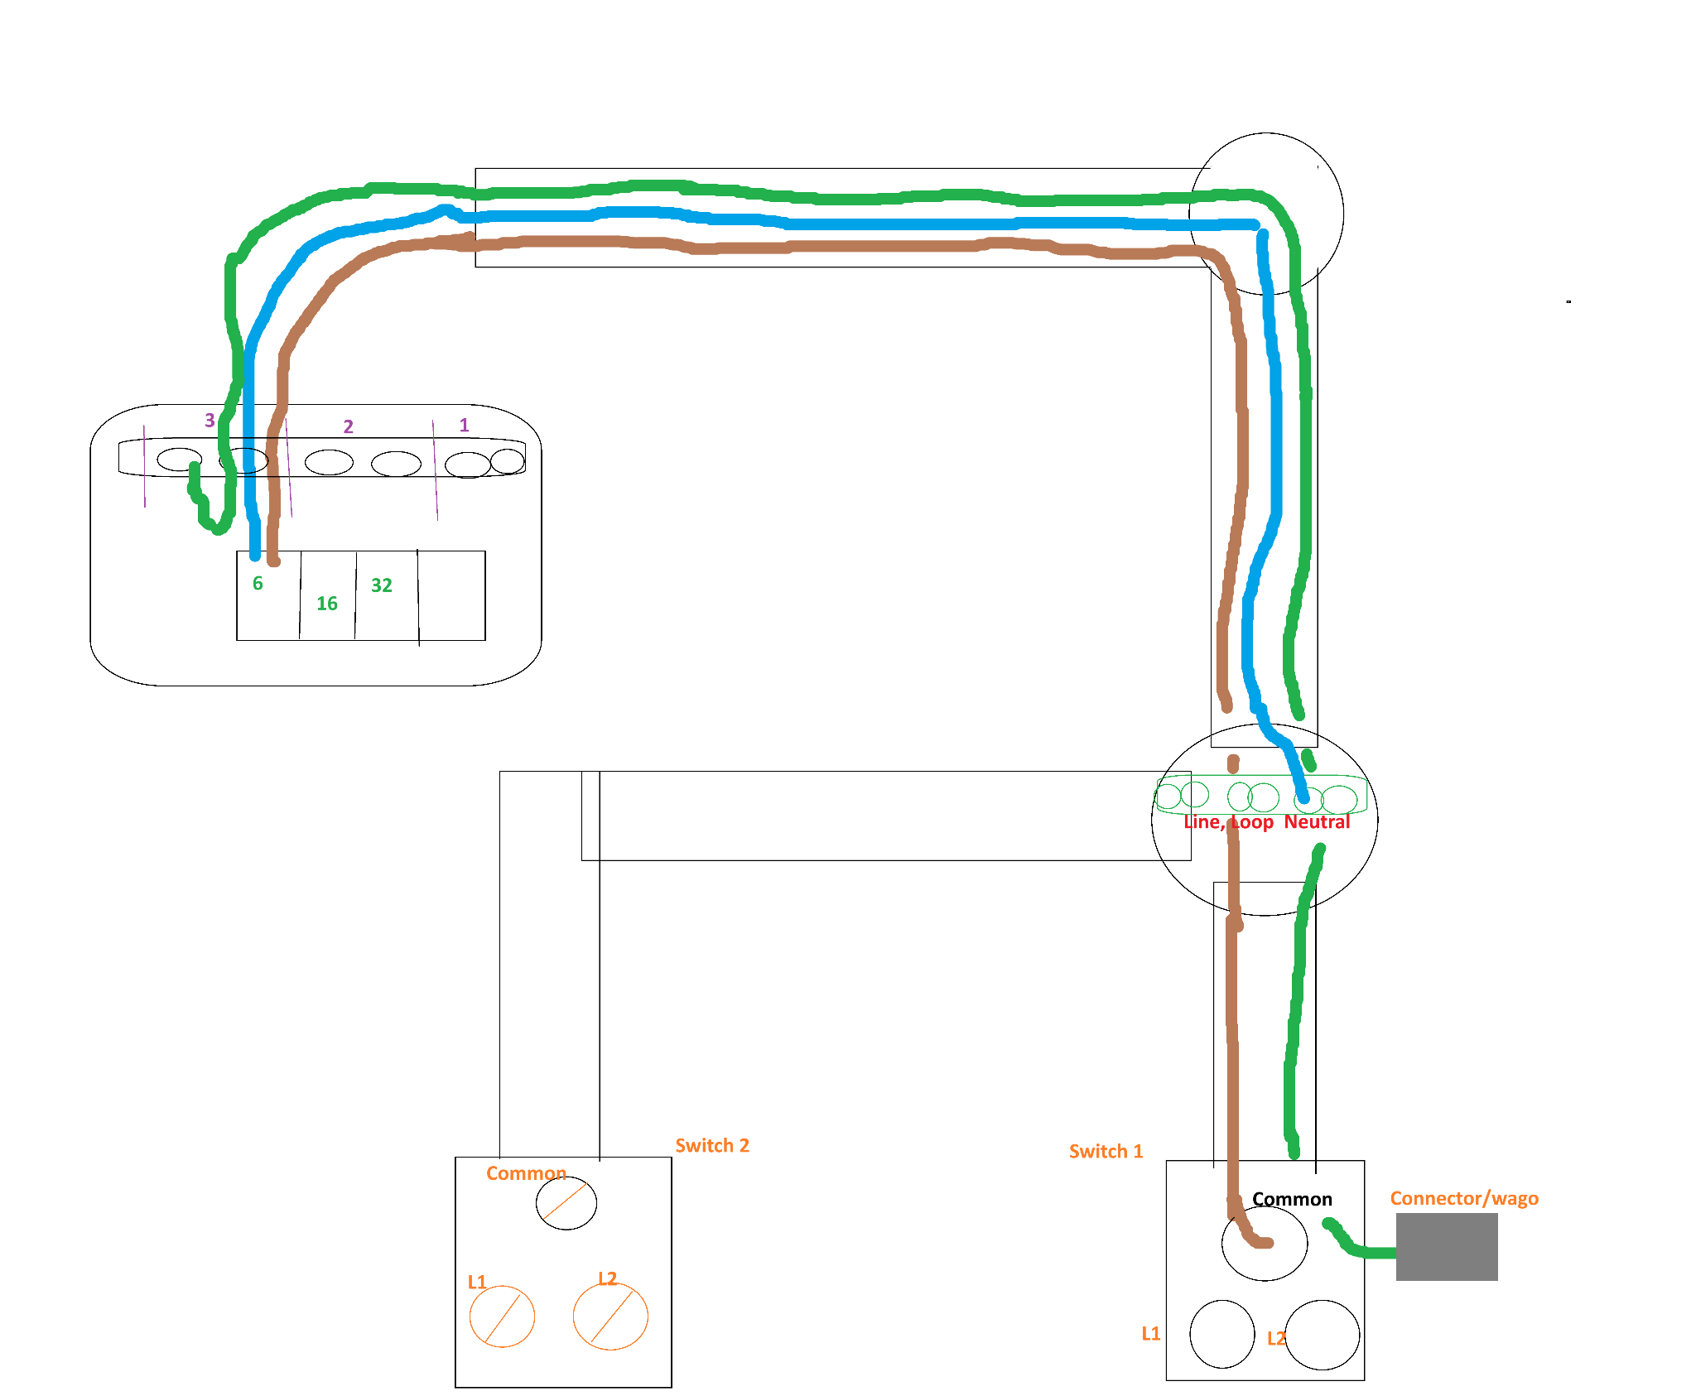

Light Switch Step Two
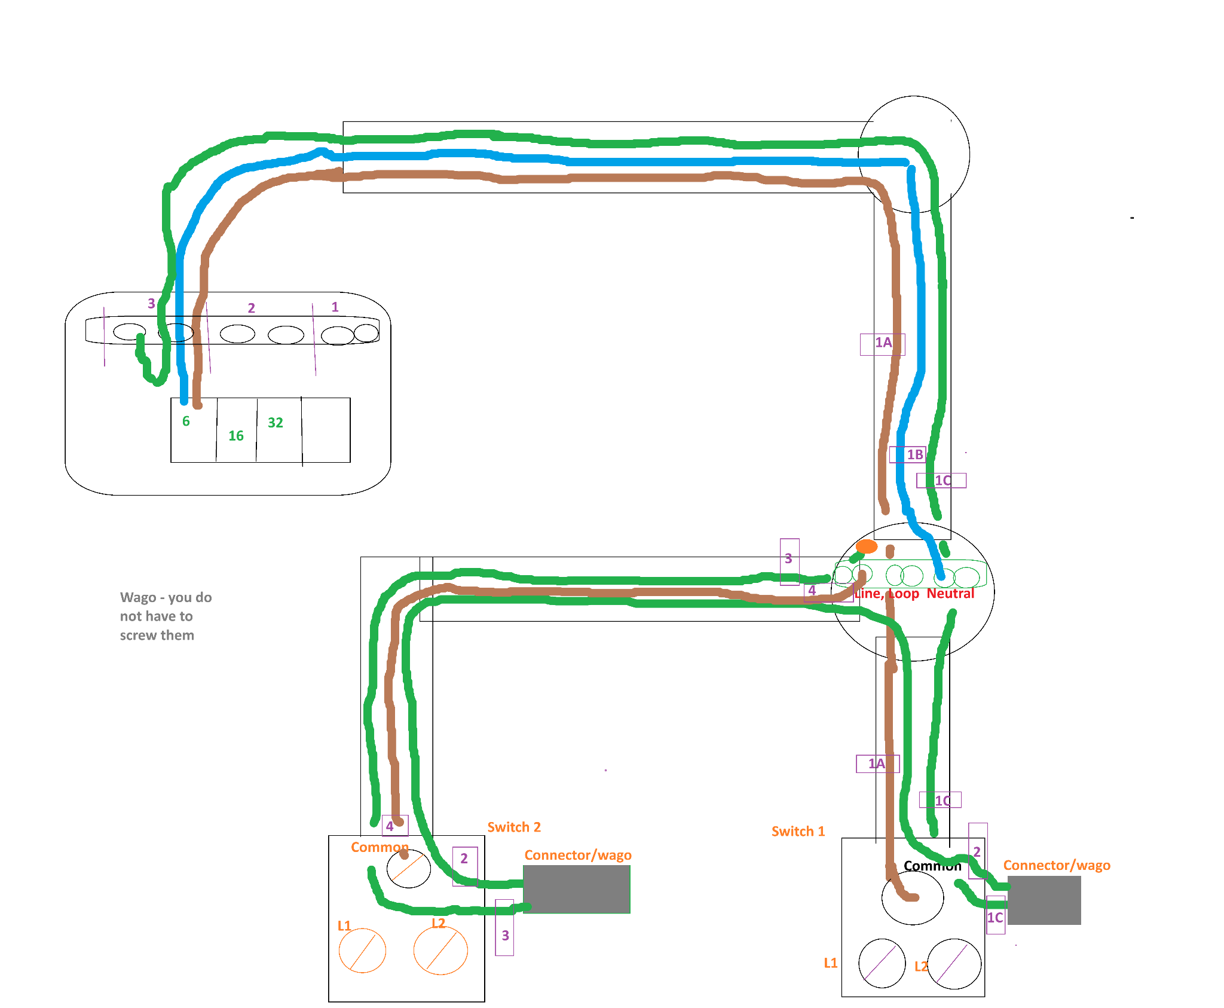

Light switch Step three
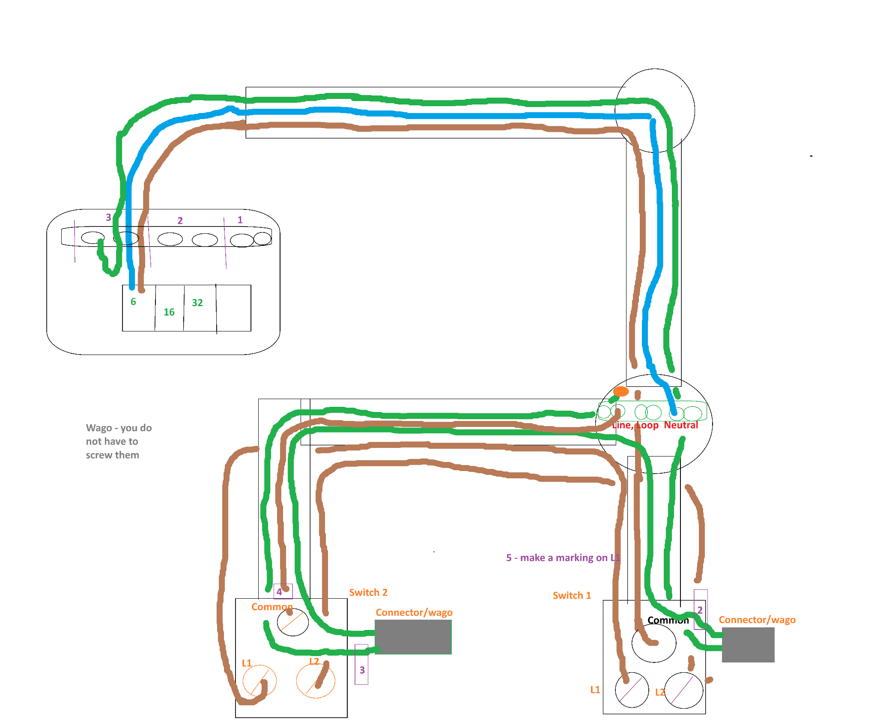

Steel conduit - Ring Circuit
The ring circuit as long as you have 2 blue 2 brown and 2 green at every point that means you will have the same at the fuse board both L and N both connected to the breaker and green to earth.

SWA Radial Circuit

The swa brown, black and grey in the fuse board black is earth. Grey is n. Don’t forget sleeving. You will be fine.

Brown => Live
Black => yellow/green sleeving => earth
Grey=> Blue sleeve => Neutral

